**CCNA 1 Chapter 10 V4.0 Answers 100% 2011**

June 7, 2011 by [admin](http://www.ccna4u.org/author/admin) · [7 Comments](http://www.ccna4u.org/2011/06/ccna-1-chapter-10-v4-0-answers-100-2011.html#comments)

Our Sponsors

[**CCNA 1 Chapter 10 V4.0 Answers 100% 2011**](http://www.ccna4u.org/2011/06/ccna-1-chapter-10-v4-0-answers-100-2011.html)  
1.

[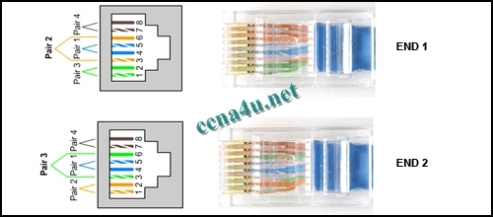](http://answers.ccna4u.net/wp-content/uploads/2011/02/1001.jpg)

**Refer to the exhibit. A student working in the lab selects a cable that is wired as shown. Which connection types can successfully be made with this cable? (Choose two.)**  
connecting a PC to a router’s console port  
connecting two routers together via their fast ethernet ports  
connecting two switches together at gigabit speeds  
connecting a PC to a switch at Gigabit Ethernet speeds  
connecting two devices with the same interface type at Fast Ethernet speeds

**2**. **Which three statements are true about the role of routers in the network? (Choose three.)**  
They propagate broadcasts.  
They enlarge collision domains.  
They segment broadcast domains.  
They interconnect different network technologies.  
Each router interface requires a separate network or subnet.  
They maintain a common frame format between LAN and WAN interfaces.

**3**.

[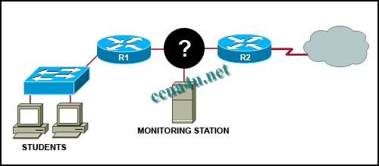](http://answers.ccna4u.net/wp-content/uploads/2011/02/1018.jpg)

**Refer to the exhibit. A network administrator has decided to use packet capture software to evaluate all traffic from the student subnet on the way to the Internet. To ensure that all packets are captured, what network device should be used to connect the monitoring station to the network between R1 and R2?**  
router  
hub  
switch  
wireless access point

**4**. **A network administrator is required to use media in the network that can run up to 100 meters in cable length without using repeaters. The chosen media must be inexpensive and easily installed. The installation will be in a pre-existing building with limited cabling space. Which type of media would best meet these requirements?**  
STP  
UTP  
coaxial  
single-mode fiber  
multimode fiber

**5**.

[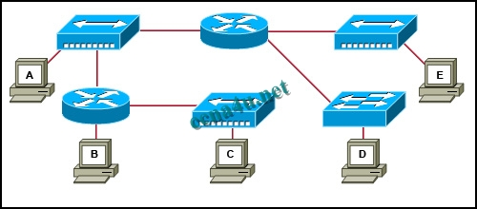](http://answers.ccna4u.net/wp-content/uploads/2011/02/1020.jpg)

**Refer to the exhibit. Which three statements are true about the exhibited topology? (Choose three.)**  
Hosts B and C are in the same subnet.  
Five broadcast domains are present.  
Host B is using a crossover cable to connect to the router.  
Four broadcast domains are present.  
Five networks are shown.  
Host B is using a rollover cable to connect to the router.

**6**. **Which three types of connectors are commonly associated with Cisco’s V.35 serial cables? (Choose three.)**  
RJ 11  
DB 60  
Winchester 15 pin  
DB 9  
smart serial  
RJ 45

**7**. **How many host addresses may be assigned on each subnetwork when using the 130.68.0.0 network address with a subnet mask of 255.255.248.0?**  
30  
256  
2046  
2048  
4094  
4096

**8**.

[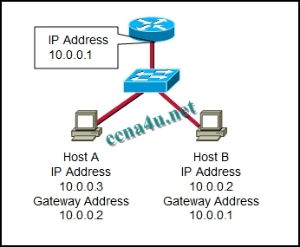](http://answers.ccna4u.net/wp-content/uploads/2011/02/1012.jpg)

**Refer to the exhibit. Based on the IP configuration shown, what would be the result of Host A and Host B attempting to communicate outside the network segment?**  
both host A and B would be successful  
host A would be successful, host B would fail  
host B would be successful, host A would fail  
both Host A and B would fail

**9**.

[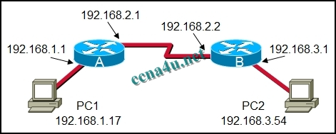](http://answers.ccna4u.net/wp-content/uploads/2011/02/10111.jpg)

**Refer to the exhibit. What destination IP address will PC1 place in the header for a packet destined for PC2?**  
192.168.1.1  
192.168.2.1  
192.168.2.2  
192.168.3.1  
192.168.3.54

**10**.

[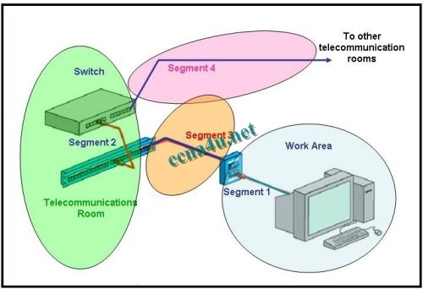](http://answers.ccna4u.net/wp-content/uploads/2011/02/1022.jpg)

**Refer to the exhibit. Which three statements identify the type of cabling that would be used in the segments that are shown? (Choose three.)**  
Segment 1 uses backbone cabling.  
Segment 1 uses a patch cable.  
Segment 3 uses patch cabling.  
Segment 3 uses vertical cabling.  
Segment 3 uses horizontal cabling.  
Segment 4 uses vertical cabling.

**11**. **A company is planning to subnet its network for a maximum of 27 hosts. Which subnet mask would provide the needed hosts and leave the fewest unused addresses in each subnet?**  
255.255.255.0  
255.255.255.192  
**255.255.255.224  
255.255.255.240  
255.255.255.248

**12**.

[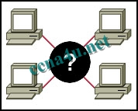](http://answers.ccna4u.net/wp-content/uploads/2011/02/1016.jpg)

**Refer to the exhibit. A student is setting up a home network primarily used for extensive file transfers, streaming video, and gaming. Which network device is best suited to these types of activities in the topology shown?**  
wireless access point  
router  
hub  
switch

**13**.

**Refer to the exhibit. How many subnets are required to support the network that is shown?**  
2  
3  
4  
5

**14**. **What does the term “attenuation” mean in data communication?**  
loss of signal strength as distance increases  
time for a signal to reach its destination  
leakage of signals from one cable pair to another  
strengthening of a signal by a networking device

**15**. **To establish a console connection from a computer to a Cisco router, which cable wiring option would be used?**  
crossover cable  
straight through cable  
rollover cable  
V.35 cable

**16**. **What makes fiber preferable to copper cabling for interconnecting buildings? (Choose three.)**  
greater distances per cable run  
lower installation cost  
limited susceptibility to EMI/RFI  
durable connections  
greater bandwidth potential  
easily terminated

**17**.

[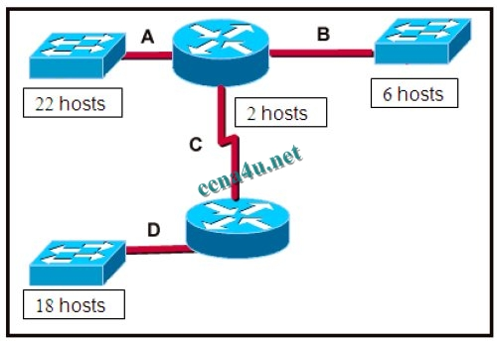](http://answers.ccna4u.net/wp-content/uploads/2011/02/1023.jpg)

**Refer to the exhibit. A network technician has been allocated the 192.168.1.0/24 private IP address range for use in the network that shown in the exhibit. Which subnet mask would be used to meet the host requirements for segment A of this internetwork?**  
255.255.255.128  
255.255.255.192  
255.255.255.224  
255.255.255.240  
255.255.255.248

**18**. **Which subnet mask would be assigned to the network address of 192.168.32.0 to provide 254 useable host addresses per subnetwork?**  
255.255.0.0  
255.255.255.0  
255.255.254.0  
255.255.248.0

**19**. **What type of network cable is used between a terminal and a console port?**  
cross-over  
straight-through  
rollover  
patch cable

**20**. **Which option identifies the primary interface which would be used for initial configuration of a Cisco router?**  
AUX interface  
Ethernet interface  
serial interface  
console interface

**21**. **What are two common methods for setting a UTP Ethernet port to MDI or MDIX operation? (Choose two.)**  
cable color code association  
cable selection and configuration  
use of cable testers to determine pinouts  
the automatic detection and negotiating of MDI/MDIX operation of the port  
the enabling of the mechanism to electrically swap the transmit and receive pairs

**22**. **Which device is used to create or divide broadcast domains?**  
hub  
switch  
bridge  
router  
repeater

**23**.

[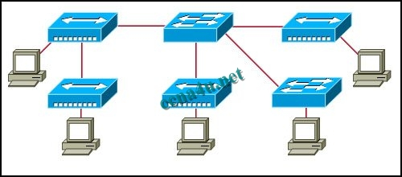](http://answers.ccna4u.net/wp-content/uploads/2011/02/1019.jpg)

**Refer to the exhibit. Assume that all devices are using default settings. How many subnets are required to address the topology that is shown?**  
1  
3  
4  
5  
7

**24**. **What are three common methods for setting a UTP Ethernet port to MDI or MDIX operation? (Choose three.)**  
direct configuration of the device  
cable color code association  
cable selection and configuration  
use of cable testers to determine pinouts  
the enabling of the mechanism to electrically swap the transmit and receive pairs  
the automatic detection and negotiating of MDI/MDIX operation of the port